**Hidden Gem of Marinduque**

A Project

Presented to the Faculty of the

School of Information and Computing Sciences

Bachelor in Information Technology

Marinduque State College

In Partial Fulfillment

of the Requirements for the subject

**INTEGRATIVE PROGRAMMING & TECHNOLOGIES**

By:

Charles Mc Vigo

Glynford Mangana

**WILMER M. PASCUAL**

Faculty

**May 2023**

**TABLE OF CONTENTS**

Page

Title Page ……………………………………………. 1

Table of Contents ……………………………………………. 2

Rubrics for Project Evaluation ……………………………………………. 3

Project Overview ……………………………………………. 5

Objectives ……………………………………………. 6

Audience …………………………………………… 7

Scope …………………………………………… 8

Features …………………………………………… 9

Functionality …………………………………………… 10

Web Page Navigation …………………………………………… 11

Web Interface Screenshot …………………………………………… 12

Technical Documentation …………………………………………… 15

Flowchart …………………………………………… 15

Source Code …………………………………………… 17

**RUBRICS FOR INTEGRATIVE PROGRAMMING –FINAL HANDS-ON EXAM**

|  |  |  |  |  |  |  |
| --- | --- | --- | --- | --- | --- | --- |
| **Schedule:** | | | **Date:** | | | |
| **Project title:** | | | | | | |
| **PROJECT CRITERIA** | **Highly Implemented**  **5** | **Satisfactory Implemented**  **4** | | **Fairly Implemented**  **3** | **Partially Implemented**  **2** | **Not Implemented**  **1** |
| **Program Source Codes** | | | | | | |
| **Syntax**  Ability to understand and follow the rules of writing PHP programs  (20%) | The application correctly executes all functions. | The program executes, but there are unnecessary codes within the program. | | Some parts of the program execute, and some parts are not. | The program doesn't execute but can be fixed easily (missing semicolon, wrong names, etc.). | Program does not execute |
| **Logic**  Ability to determine appropriate conditions and the overall flow of the program  (15%) | Program logic is correct. | Program is correct but program logic contains errors and redundancy. | | Program has some logical errors that may just be miscalculations on conditions. | Program logic does not conform to the directions. | No logic is applied to the program at all. |
| **Correctness**  Ability to write appropriate algorithms that give the correct output. (20%) | Program produces the correct output based on the input given | Program produces correct output on most inputs. | | Program output are almost correct and has some minor miscalculations | Very few correct outputs are found. | Program output is incorrect. Needs major rework in calculations. |
| **Program Design**  Ability to design a proper UI for the users to interact with the program. (30%) | Design is well thought. Design doesn't hinder the user experience. | Design is well-thought and is aesthetically pleasing | | Design is lacking in places | The design is inappropriate to the topic | Design needs improvement and the program is not user friendly |
| **Code Organization**  Ability to write well-organized and structured code. (10%) | Objects are named descriptively and appropriately for their purpose; code is consistently and clearly organized, commented, and indented.. | Objects are mostly named appropriately, but some could be more descriptive; code is mostly organized, commented, and indented, with a few minor issues such as inconsistent indentation or naming conventions | | Objects are fairly named appropriately, but some could be most descriptive; code is mostly organized, commented, and indented, with a few minor issues such as inconsistent indentation or naming conventions | Objects are inconsistently or poorly named, making their purpose unclear; code is generally unorganized and difficult to follow, with issues such as poor indentation, inconsistent naming conventions, and few or no comments | Object names are unclear or use default names, making it difficult to understand their purpose; code is disorganized and unreadable, with little or no indentation, no comments, and inconsistent naming conventions. |
|  |  |  | |  |  |  |
| **DOCUMENTATION** | | | | | | |
| **Completeness/Correctness**  Ability to present the required document correctly.  (5%) | All the required parts of the document are present and correct. | All parts of the documents are present with minimal incorrect parts. | | Some parts of the document are missing. | Most parts of the documents are missing and a lot of incorrect parts were observed. | No documentation was presented at all. |
| **TOTAL** |  | | | | | |
| **REMARKS** |  | | | | | |

|  |  |  |  |
| --- | --- | --- | --- |
| **Name of Student** | **Presentation/Q&A**  **50%** | **Project Rating**  **50%** | **Total**  **Rating**  **100%** |
| 1. **LN, FN MI** 2. **LN, FN MI** |  |  |  |

**Evaluated by:**

_______________________________________

**WILMER M. PASCUAL**

**I. PROJECT OVERVIEW**

Marinduque is a stunning island that is located at the heart of Philippines, have a vast mysterious natural wonders, cultural heritage and excellent service and hospitality from the natives. Marinduque Tourism Guide is created to provide the best experience to explore and to have exposure to the tourist spots and events in Marinduque. The Marinduque Tourism Guide is a free and valuable website that will serve as a gateway to captivate more foreign tourist to visit Marinduque.

The Marinduque Tourism Guide project that we created was focused to attracts foreign tourist to visit Marinduque for a new experience in the culture and heritage of Marinduque not just from a long time ago but also the new and improvised tourist spots and events in Marinduque. This website will also provide up-to-date information, hotel or resorts to stay, budget management, best time to visit and other related detail. Marinduque Tourism Guide website will be made prioritizing our foreign tourist’s sake, so the website will have an easy and user-friendly interface that will maximize the experience of the tourist when browsing the website.

Overall, the Marinduque Tourism Guide is a website that will provide various information to our guest and tourist from other places. This will also be a way to help the province as a fellow native to advertise it to make the province livelier and more energetic. In the end, the aim of the website is to promote the tourism of Marinduque. The Marinduque Tourism Guide website serves as a comprehensive and user-friendly resource for travelers seeking to relax and explore the wonders of Marinduque. With its detailed information on cultural heritage, natural landscapes, and practical tips, and community engagement, the website invites travelers and tourists to unlock the secrets of this captivating destination, leaving them with lasting memories and a desire to return.

**Objectives**

The Marinduque Tourism PHP Scripting project had the objective to disseminate information to the tourist that are interested to go and tour in Marinduque. This tourist website aims to provide accurate and comprehensive information about the destination, including some cultural background, landmarks, the best date to go, prices and budget management and other relevant information. The tourist website will provide the best possible experience to our visitors.

This tourist website will also be the gateway to promote the cultural heritage of Marinduque as a must visit destination in the Philippines. By providing detailed information about the province’s culture and heritage, natural attraction, travel tips and other relevant information, the website aims to showcase the beauty and uniqueness of Marinduque. The website also highlights local business, artisan and entrepreneurs, providing them exposure and support. This will also enhance the business of the natives in Marinduque, it will not only just be promoting the places and events in this province but also the business of the people. It will be a very good way to attract tourists from other places and at the same time promotes the business of our own people.

Finally, the Marinduque Tourism website aims to satisfy the needs of our instructor, for they are the one to tell us create this website as a way of completing this semesters subject. This is the most important objective in creating this tourist website in Marinduque and that is to pass this subject by doing this final output that was instructed to us by our teacher in the subject. Creating this website needs a very detailed information about the tourist spots and events and should also have a good design, at the same time a good user interface.

Overall, the Marinduque Tourism Guide website has three main objectives: to provide detailed and user-friendly information for guests and tourists, to promote the must visit destination in the province and finally to satisfy our instructor in this subject and pass. By achieving these objectives, the website will definitely contribute to the growth and development of Marinduque’ tourism industry while showcasing the beauty and nature of this remarkable island of Marinduque.

**Audience**

The Marinduque Tourist website have two major audience and that is the tourists that will visit the province’s natural spots and destination and the other is the local and native businessmen, entrepreneur and artisans that is governing the natural spots and destinations in Marinduque. The website is not only for foreign tourist but also for the local tourist that haven’t yet explore the province. The website’s content will be in universal language, “English”, to ensure that the tourist can easily understand the information in the website.

Aside from the foreign and local tourists, the other audience for this subject will be the local businessmen, artisans, and entrepreneurs. The website will serve as a way so that their product and services will be promoted to the tourists. This method will provide a good path for more employment in Marinduque, making the province livelier and have more economic employment for our native.

Finally, there is actually another audience that can enter the discussion of the Marinduque Tourist Guide website which are the individuals and organizations outside the province that are interested in collaborating and promoting their own businesses. This will provide for more employment opportunities for our province and this cause will make the province lean in the development side. The project can be a marketing strategy that our own people can use for their own advantage for free promotion of their own businesses.

**Scope**

The Marinduque Tourism Guide project that we created was focused to attracts foreign tourist to visit Marinduque for a new experience in the culture and heritage of Marinduque not just from a long time ago but also the new and improvised tourist spots and events in Marinduque. The website’s content will be in universal language, “English”, to ensure that the tourist can easily understand the information in the website. The project can be a way to provide more employment opportunities for our local workers. The website will also serve as a gateway to promote the natural destinations and other tourist spots in Marinduque. Not only will the project serve as a way to promote the natural destinations in the province but it will also unconditionally promote our businessmen, artisans, and entrepreneur’s businesses. Aside from that, this project will further enhance the development of the province into a more massive community. Different enterprise and business will emerge from the promotion of the natural destination and businesses and this will attract more tourists to visit the province. The project will also provide the users to have an easy access to the website so that they will have a relaxed and good impression of the website. The website will provide the tourists a detailed up-to-date information about the tourists’ spots and events they will visits. Aside from that, the website will also provide some multimedia content such as images to make the tourist have some more overview about the beauty of the natural destination of the province. Lastly, the most important part of the project is to use it to provide more job-related opportunities to our own people so that they can also contribute to the growth and development of our own province since many talented people leave their homeland just too successful since there is a limited opportunities in the province so the development of Marinduque will take place using the marketing of the businesses using the website.

**Features**

The Marinduque Tourist Guide website will offer various kinds of features to our tourists that will improve the experience of the tourists and promote the Marinduque tourism. This tourist website aims to provide accurate and comprehensive information about the destination, including some cultural background, landmarks, the best date to go, prices and budget management and other relevant information. Aside from that, the website will also provide some multimedia content such as images to make the tourist have some more overview about the beauty and uniqueness Marinduque. The website’s content will be in universal language, “English”, to ensure that the tourist can easily understand the information in the website. In summary, the tourist guide website will serve as a one-stop resource for travelers and tourists, offering a wealth of information and user generated content. Whether seeking historical sites, natural wonders, or cultural experience, tourist can rely on this website to navigate their way and make the most of their adventures.

**Functionality**

The project will serve as a way to assist travelers and tourist in planning, managing budget, and organizing their trips effectively. Firstly, it acts as an information hub, providing comprehensive details about various destinations, hotels and resort, restaurants, including popular attractions, landmarks, historical sites, local culture and events. This helps travelers and tourist gain insights into the places they wish to visit and enables them to make informed decisions about their choices. One key function of the project is its ability to search the tourist spots and events in a certain town by just typing the name of the town. In addition to that, we also provided the users the places they can stay like hotel and resorts near the tourist spots or events. So, if their visit takes more than day, they can spend the night in one of the hotels and resort provided in the same town. Not only that, we also added the restaurants, cafe and bar they can visit, this will ensure that it the user will have it easier to find dining place when they are hungry and so that they can try local dishes.

**II. PROJECT NAVIGATION**

The navigation of the website will start with the homepage which will serve as the main entry point for users and should provide a visually appealing and intuitive design. The homepage will be featured by a prominent search bar where users can enter the name of their desired destination or browse through popular destinations. The homepage will also showcase attractions or destinations, along with enticing images and brief descriptions.

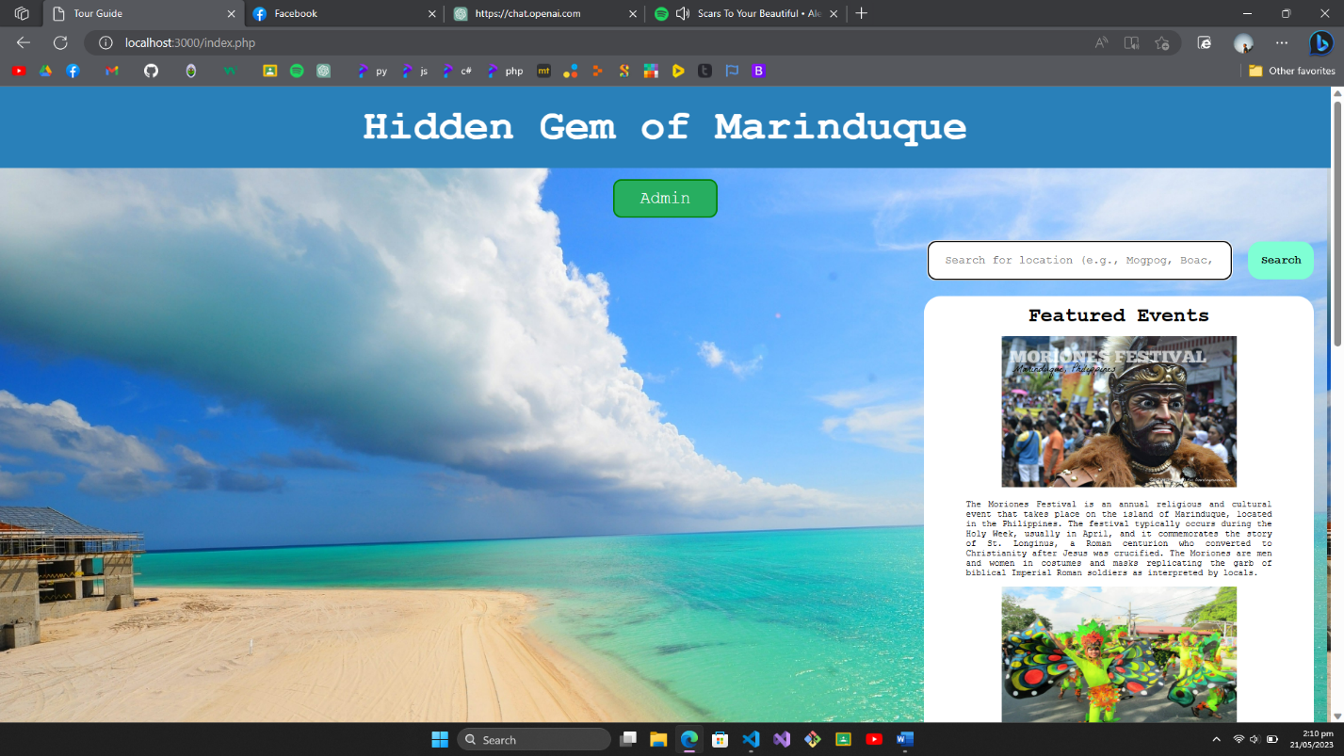

***Figure 1. Homepage***

The figure 1 is the main homepage of the website. This page has the search feature where the user has to enter the name of the place or municipality they want to visit and then the tourist spots and events will appear. Featured events are also present in home page.

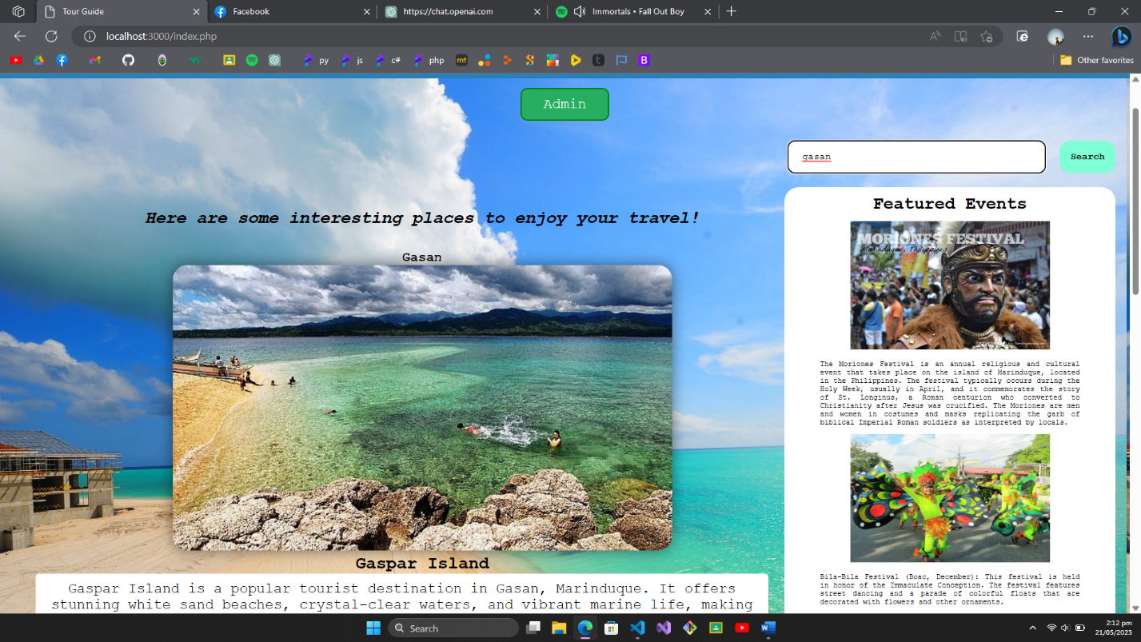

***Figure 2. Search Page***

On the figure 2, we can see the result of the searched place. The tourist spots and events will appear here once they are search.

**Interface**

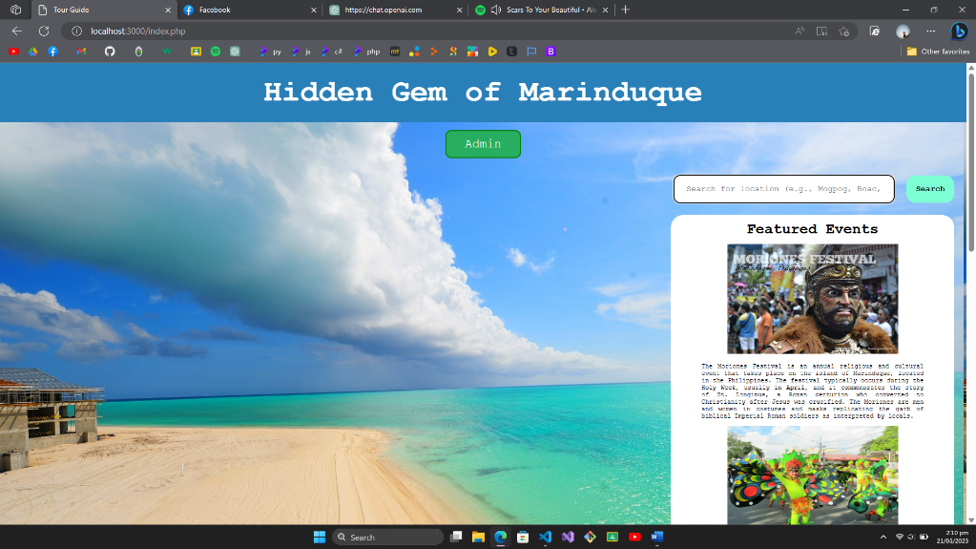

***Figure 1. Homepage***

The figure 1 is the main homepage of the website. This page has the search feature where the user has to enter the name of the place they want to visit and then the tourist spots and events will appear.

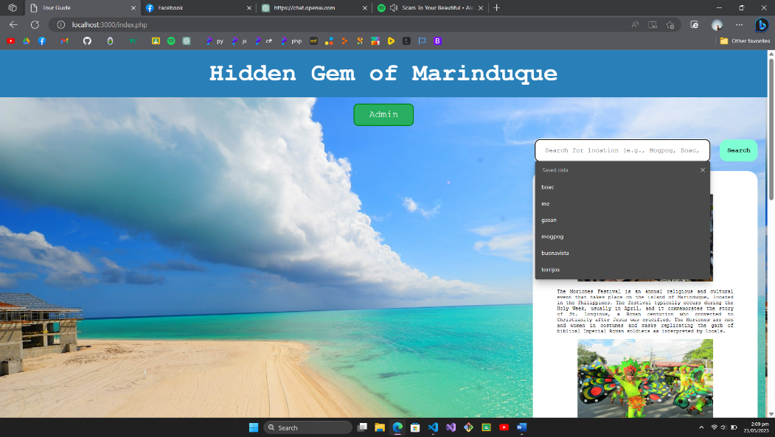

***Figure 2. Search Page***

On the figure 2, we can see the result of the searched place. The tourist spots and events will appear here once they are search.

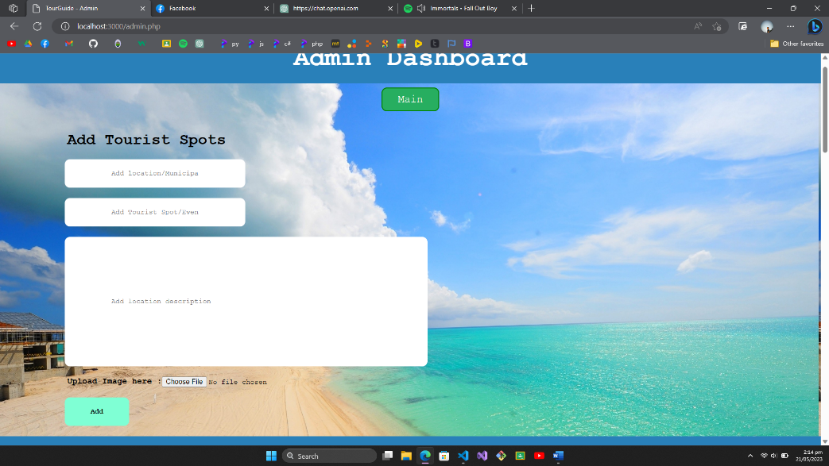

***Figure 3. Admin Page***

The figure 2 will be the page where the contents of the website will be placed. Here, we used xml to input the content to the website, the municipality, name of tourist spots or events and the description included.

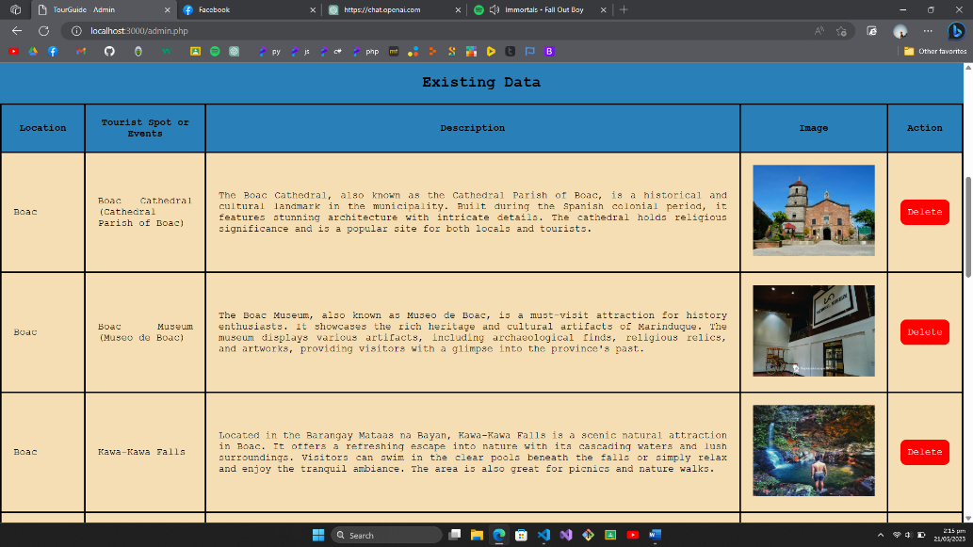

***Figure 4. Stored Content***

Figure 4 is the result of adding contents in admin. Now the contents are stored in this page. This table can be found below the admin page and inputs.

**III. Technical documentation**

**flowchart**

**MAin page (index.php)**

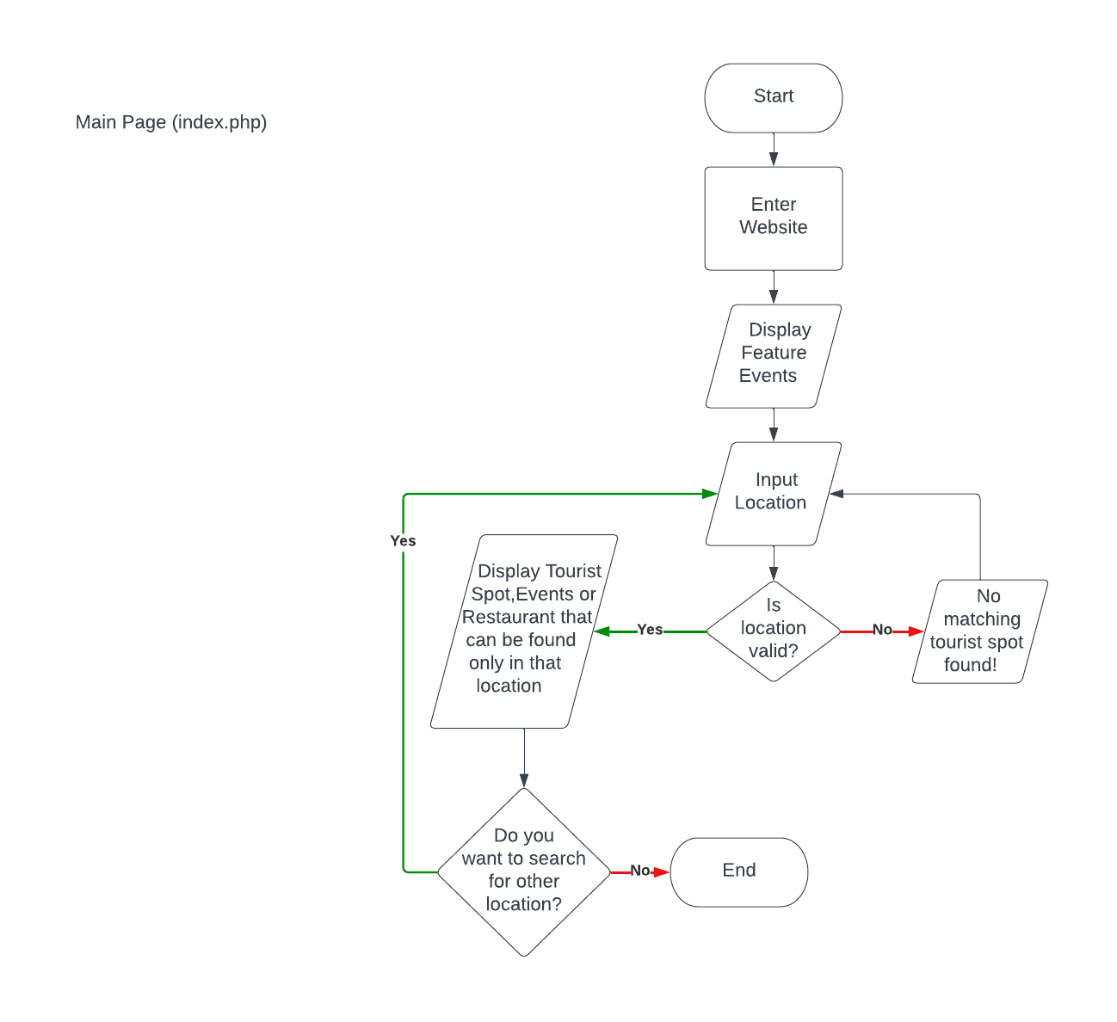

**Figure 1. Main Page**

This shows the functionality on how to Tourist Spot would appear in the website. If the searched location is validc, the location will appear in the website, else no tourist matching tourist spot found will occur.

**Admin Page (admin.php)**

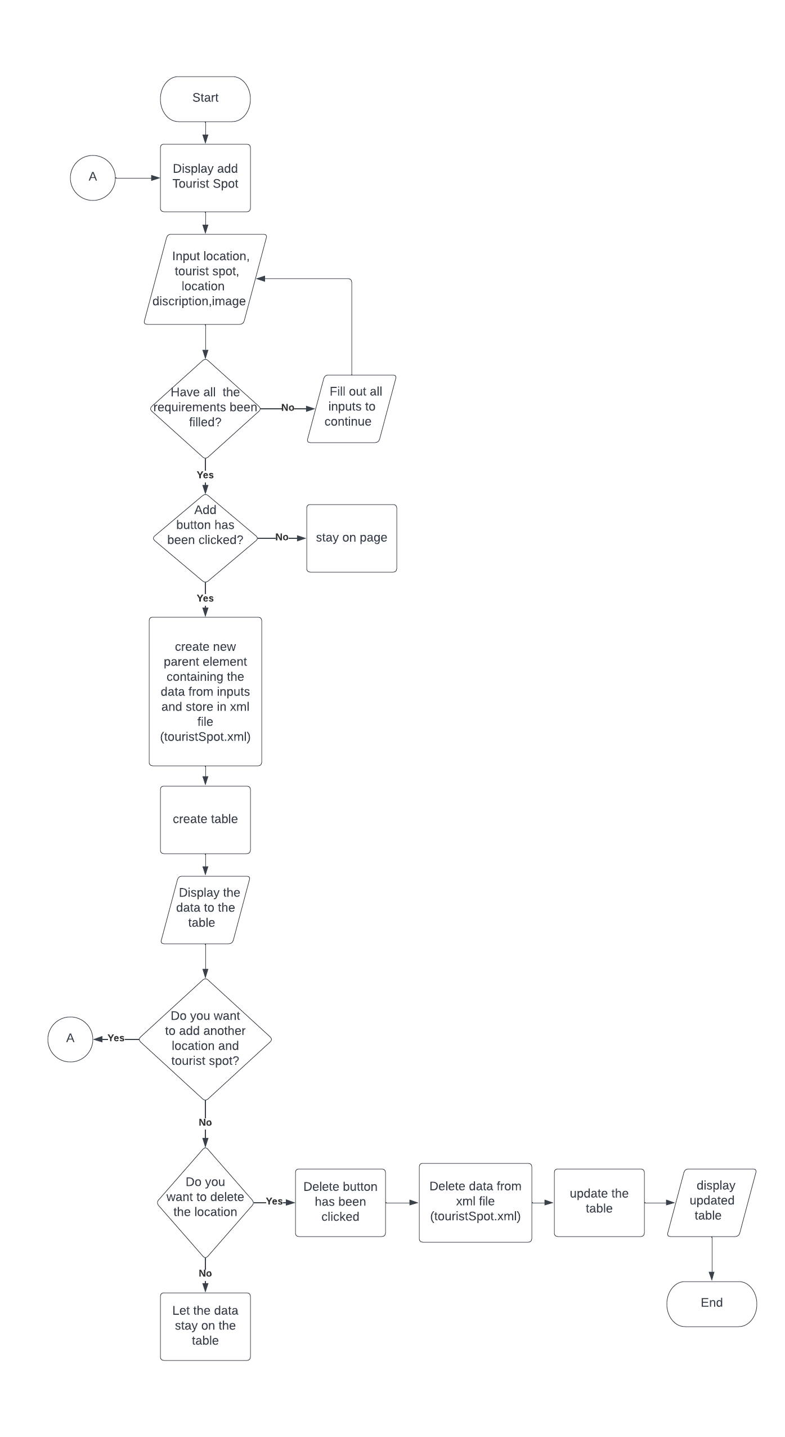

**Figure 2. Admin Page**

Figure 2 shows how the location or tourist Spot data are created and stored in xml file. After filling up all the required input, once add button was clicked, data from input field will be stored in an xml file as new parent and child elements. After successfully adding new data to xml file, this can be deleted by clicking delete button, doing this will erase specific data on xml file.

**Source Code**

**Main page (index.php)**

<!DOCTYPE html>

<html lang="en">

<head>

    <meta charset="UTF-8">

    <meta http-equiv="X-UA-Compatible" content="IE=edge">

    <meta name="viewport" content="width=device-width, initial-scale=1.0">

    <title>Tour Guide</title>

    <link rel="stylesheet" href="styles.css">

</head>

<body>

    <section>

        <div class="head-navi">

            <h1 class="banner">Hidden Gem of Marinduque</h1>

            <ul>

                <li>

                    <a href="admin.php">Admin</a>

                </li>

            </ul>

            <form action="" method="post">

                <div class="search-bar">

                    <input type="text" id="search" name="search-location" placeholder="Search for location (e.g., Mogpog, Boac, Santa Cruz, etc.">

                    <input type="submit" id="search-button" value="Search">

                </div>

            </form>

            <div class="featured-events">

                <h2>Featured Events</h2>

                <img src="moriones_festival.jpg" alt="moriones festival">

                <p>The Moriones Festival is an annual religious and cultural event that takes place on the island of Marinduque, located in the Philippines. The festival typically occurs during the Holy Week, usually in April, and it commemorates the story of St. Longinus, a Roman centurion who converted to Christianity after Jesus was crucified. The Moriones are men and women in costumes and masks replicating the garb of biblical Imperial Roman soldiers as interpreted by locals.</p>

                <img src="bila bila fest.jpg" alt="bilabila festival">

                <p>Bila-Bila Festival (Boac, December): This festival is held in honor of the Immaculate Conception. The festival features street dancing and a parade of colorful floats that are decorated with flowers and other ornaments.</p>

                <img src="kangga fest.jpg" alt="kangga festival">

                <p>Kangga Festival (Mogpog, May): This festival is a celebration of the town’s patron saint, St. Isidore the Farmer. The festival features street dancing and a parade of colorful floats that are decorated with flowers and other ornaments.</p>

                <img src="haring_karabaw_festival.JPG" alt="haring karabaw festival">

                <p>Haring Karabaw Festival (Santa Cruz, January): This festival is held in honor of the carabao, which is considered as the farmer’s best friend. The festival features a parade of carabaos that are dressed up in colorful costumes and decorated with flowers and other ornaments.</p>

                <img src="kalesayahan fest.jpg" alt="kalesayahan festival">

                <p>Kalesayahan sa Gasan (Gasan, August): This festival is a celebration of the town’s founding anniversary. The festival features street dancing and a parade of colorful floats that are decorated with flowers and other ornaments.</p>

                <img src="kalutang_festival.jpg" alt="kalutang festival">

                <p>Kalutang Festival (February): This festival is a celebration of the traditional bamboo instrument called kalutang. The festival features performances by local musicians who play the kalutang and other traditional instruments.</p>

            </div>

        </div>

    </section>

    <section>

        <div class="data-searched">

            <?php

            if ($_SERVER['REQUEST_METHOD'] === 'POST') {

                $searchLocation = $_POST['search-location'];

                $xml = simplexml_load_file('touristSpot.xml');

                $matchingSpots = $xml->xpath("//TouristLocation[translate(Location, 'ABCDEFGHIJKLMNOPQRSTUVWXYZ', 'abcdefghijklmnopqrstuvwxyz') = translate('$searchLocation', 'ABCDEFGHIJKLMNOPQRSTUVWXYZ', 'abcdefghijklmnopqrstuvwxyz')]");

                if (!empty($matchingSpots)) {

                    echo '<h2 id="result-text"><i> Here are some interesting places to enjoy your travel!</i></h2>';

                    foreach ($matchingSpots as $spot) {

                        echo '<div class="location">';

                        echo '<h3>' . $spot->Location . '</h3>';

                        if (isset($spot->Image)) {

                            echo '<a href="' . $spot->Image . '"><img src="' . $spot->Image . '" alt="Location Image"></a>';

                        }

                        echo '<h2>' . $spot->TouristSpots_Events . '</h2>';

                        echo '<p id="description-size">' . $spot->Description . '</p>';

                        echo '</div>';

                    }

                } else {

                    echo '<p id="no-result">No matching tourist spots found.</p>';

                }

            }

            ?>

        </div>

    </section>

</body>

</html>

**Admin page (admin.php)**

<?php

    function addTouristSpot($location, $touristSpot_Events, $description, $image)

    {

        $xml = simplexml_load_file('touristSpot.xml');

        if (!$xml) {

            $xml = new SimpleXMLElement('<TouristSpots></TouristSpots>');

        }

        $newLocation = $xml->addChild('TouristLocation');

        $newLocation->addChild('Location', $location);

        $newLocation->addChild('TouristSpots_Events', $touristSpot_Events);

        $newLocation->addChild('Description', $description);

        $imageFileName = $image['name'];

        $imageFolderPath = 'uploads/' . $touristSpot_Events;

        if (!is_dir($imageFolderPath)) {

            mkdir($imageFolderPath, 0777, true);

        }

        $imageFilePath = $imageFolderPath . '/' . $imageFileName;

        move_uploaded_file($image['tmp_name'], $imageFilePath);

        $newLocation->addChild('Image', $imageFilePath);

        $xml->asXML('touristSpot.xml');

        header("Location: admin.php");

        exit();

    }

    function deleteTouristSpot($location)

    {

        $xml = simplexml_load_file('touristSpot.xml');

        $deletedLocation = $xml->xpath("//TouristLocation[Location = '{$location}']");

        if (!empty($deletedLocation)) {

            $deletedLocation = $deletedLocation[0];

            $imageFilePath = (string) $deletedLocation->Image;

            if (file_exists($imageFilePath)) {

                unlink($imageFilePath);

            }

            $imageFolderPath = dirname($imageFilePath);

            if (is_dir($imageFolderPath)) {

                $files = glob($imageFolderPath . '/*');

                foreach ($files as $file) {

                    if (is_file($file)) {

                        unlink($file);

                    }

                }

                rmdir($imageFolderPath);

            }

            unset($deletedLocation[0]);

            $xml->asXML('touristSpot.xml');

        }

    }

    if ($_SERVER['REQUEST_METHOD'] === 'POST' && isset($_POST['location']) && isset($_POST['touristSpotOrEvents']) && isset($_POST['location-description'])) {

        $location = $_POST['location'];

        $touristSpot_Events = $_POST['touristSpotOrEvents'];

        $description = $_POST['location-description'];

        $image = $_FILES['image'];

        addTouristSpot($location, $touristSpot_Events, $description,$image);

    }

    if ($_SERVER['REQUEST_METHOD'] === 'GET' && isset($_GET['delete'])) {

        $location = $_GET['delete'];

        deleteTouristSpot($location);

        header("Location: admin.php");

        exit();

    }

    $xml = simplexml_load_file('touristSpot.xml');

?>

<!DOCTYPE html>

<html lang="en">

<head>

    <meta charset="UTF-8">

    <meta http-equiv="X-UA-Compatible" content="IE=edge">

    <meta name="viewport" content="width=device-width, initial-scale=1.0">

    <title>TourGuide - Admin</title>

    <link rel="stylesheet" href="styles.css">

</head>

<body>

    <section>

        <div class="admin-main">

            <div class="content-container">

                <form action="admin.php" method="post" enctype="multipart/form-data">

                    <h1 class="banner">Admin Dashboard</h1>

                    <ul>

                        <li>

                            <a href="index.php">Main</a>

                        </li>

                    </ul>

                    <h3 class="label-add">Add Tourist Spots</h3>

                    <input type="text" name="location" placeholder="Add location/Municipality" required>

                    <input type="text" name="touristSpotOrEvents" placeholder="Add Tourist Spot/Events" required>

                    <input type="text" name="location-description" placeholder="Add location description" class="description-container" required>

                    <label for="image" id="label-upload" >Upload Image here :<input type="file" name="image" accept="image/*" required></label>

                    <input type="submit" value="Add">

                </form>

            </div>

        </div>

    </section>

    <section>

        <div class="data-container">

            <h3>Existing Data</h3>

            <table>

                <tr>

                    <th>Location</th>

                    <th>Tourist Spot or Events</th>

                    <th>Description</th>

                    <th>Image</th>

                    <th>Action</th>

                </tr>

                <?php

                    foreach ($xml->TouristLocation as $index => $location) {

                        echo '<tr>';

                        echo '<td>' . $location->Location . '</td>';

                        echo '<td>' . $location->TouristSpots_Events . '</td>';

                        echo '<td id="Description-data">' . $location->Description . '</td>';

                        echo '<td><img src="' . $location->Image . '" alt="Image"></td>';

                        echo '<td><a href="admin.php?delete=' . urlencode($location->Location) . '" id="delete-button">Delete</a></td>';

                        echo '</tr>';

                    }

                ?>

            </table>

        </div>

    </section>

</body>

</html>

**CSS (style.css)**

*{

    margin: 0;

    padding: 0;

    box-sizing: border-box;

    font-family:'Courier New', Courier, monospace;

}

body {

    position: relative;

    background-image: url("bg\ marinduque.jpg");

    background-size: cover;

    background-attachment: fixed;

}

.banner{

    position: relative;

    padding: 20px;

    background-color: #2980b9;

    color: white;

    font-size: 50px;

    max-width: 100%;

}

#result-text{

    text-align: center;

    padding: 30px;

    margin-right: 400px;

}

#no-result{

    margin: 0 130px;

    font-size: 30px;

}

.head-navi{

    text-align: center;

}

.head-navi ul li{

    list-style: none;

    text-align: center;

    margin-top: 25px;

    margin-bottom: 20px;

}

.head-navi a{

    border-radius: 10px;

    border: 2px solid green;

    color: white;

    background-color: #27ae60;

    text-decoration: none;

    padding: 10px 30px;

    font-size: 20px;

    margin: 10px;

}

.head-navi a:hover{

    background-color: green;

}

.search-bar{

    display: flex;

    padding: 0 350px;

    padding-left: 980px;

    padding-right: 0;

}

#search{

    padding: 0 20px;

    border-radius: 10px;

    background-color: white;

    margin-right: 0;

    border: none;

    flex: 1;

}

#search-button{

    border-radius: 15px;

    background-color: aquamarine;

    border: none;

    margin-left: 20px;

    padding: 15px;

    margin-right: 20px;

}

.data-searched {

    display: flex;

    flex-direction: column;

    align-items: center;

}

.location {

    flex-direction: column;

    align-items: center;

    text-align: center;

    margin-bottom: 20px;

    margin-right: 300px;

}

.location h3{

    margin-right: 100px;

}

.location h2{

    margin-right: 100px;

}

.location img{

    margin-right: 100px;

    box-shadow: 0 0 20px rgba(0, 0, 0, 0.5);

}

.featured-events{

    padding: 10px 0;

    background-color: white;

    position: absolute;

    display: block;

    margin: 0 0 0 1100px;

    margin-right: 20px;

    border-radius: 20px;

}

.featured-events img{

    height: 200px;

    width: 300px;

    padding: 10px;

}

.featured-events p{

    font-size: 10px;

    text-align: justify;

    margin: 0 50px;

}

.label-add{

    text-align: left;

    margin-left: 130px;

    max-width: 100%;

    font-size: 30px;

}

.content-container{

    position: relative;

    justify-content: center;

    align-items: center;

    text-align: center;

    width: 100%;

}

input[type="text"]{

    border-radius: 10px;

    padding: 20px 90px;

    background-color: white;

    display: block;

    margin: 20px 125px;

    border: none;

}

input[type="submit"]{

    border-radius: 10px;

    background-color: aquamarine;

    display: block;

    margin: 20px 125px;

    padding: 20px 50px;

    font-weight: bold;

    border: none;

}

.content-container ul li{

    list-style: none;

    margin: 20px 30px;

    margin-bottom: 50px;

}

.content-container a{

    border-radius: 10px;

    border: 2px solid green;

    color: white;

    background-color: #27ae60;

    text-decoration: none;

    padding: 10px 30px;

    font-size: 20px;

    margin: 10px;

}

.content-container a:hover{

    background-color: green;

}

.description-container{

    max-width: 100%;

    width: 700px;

    height: 250px;

    border: none;

}

.data-container h3{

    background-color: #2980b9;

    font-size: 25px;

    text-align: center;

    padding: 20px;

}

.data-container table {

    width: 100%;

    background-color: #2980b9;

    border-collapse: collapse;

}

.data-container table th {

    text-align: center;

    padding: 20px;

    border: 3px solid black;

}

.data-container table td {

    padding: 20px;

    background-color: wheat;

    text-align: justify;

    border: 3px solid black;

}

#label-upload{

    display: flex;

    margin-left: 130px;

    font-weight: bold;

}

table img {

    width: 200px;

    height: 150px;

}

table {

    width: 100%;

    border-collapse: collapse;

}

th, td {

    padding: 8px;

    text-align: center;

    border-bottom: 1px solid #ddd;

}

.location img {

    border-radius: 20px;

    width: 700px;

    height: 400px;

    object-fit: cover;

}

#delete-button{

    text-decoration: none;

    color: white;

    border: 2px solid red;

    padding: 10px;

    border-radius: 10px;

    background-color: red;

}

#description-size{

    font-size: 20px;

    max-width: 80%;

    margin: 0 50px;

    background-color: white;

    padding: 10px;

    border-radius: 5px;

}

**XML File (touristSpot.xml)**

<?xml version="1.0"?>

<TouristSpots>

    <TouristLocation>

        <Location>Boac</Location>

        <TouristSpots_Events>Boac Cathedral (Cathedral Parish of Boac)</TouristSpots_Events>

        <Description>The Boac Cathedral, also known as the Cathedral Parish of Boac, is a historical and cultural landmark in the municipality. Built during the Spanish colonial period, it features stunning architecture with intricate details. The cathedral holds religious significance and is a popular site for both locals and tourists.</Description>

        <Image>uploads/Boac Cathedral (Cathedral Parish of Boac)/boac cathedral.jpg</Image>

    </TouristLocation>

    <TouristLocation>

        <Location>Boac</Location>

        <TouristSpots_Events>Boac Museum (Museo de Boac)</TouristSpots_Events>

        <Description>The Boac Museum, also known as Museo de Boac, is a must-visit attraction for history enthusiasts. It showcases the rich heritage and cultural artifacts of Marinduque. The museum displays various artifacts, including archaeological finds, religious relics, and artworks, providing visitors with a glimpse into the province's past.</Description>

        <Image>uploads/Boac Museum (Museo de Boac)/boac museum.jpg</Image>

    </TouristLocation>

    <TouristLocation>

        <Location>Boac</Location>

        <TouristSpots_Events>Kawa-Kawa Falls</TouristSpots_Events>

        <Description>Located in the Barangay Mataas na Bayan, Kawa-Kawa Falls is a scenic natural attraction in Boac. It offers a refreshing escape into nature with its cascading waters and lush surroundings. Visitors can swim in the clear pools beneath the falls or simply relax and enjoy the tranquil ambiance. The area is also great for picnics and nature walks.</Description>

        <Image>uploads/Kawa-Kawa Falls/Kawa-Kawa Falls.jpg</Image>

    </TouristLocation>

    <TouristLocation>

        <Location>Buenavista</Location>

        <TouristSpots_Events>Poctoy White Beach</TouristSpots_Events>

        <Description>Poctoy White Beach is a beautiful stretch of white sand beach located in Buenavista. It offers crystal-clear waters and a tranquil atmosphere, making it an ideal spot for swimming, sunbathing, and picnicking. The beach also provides stunning views of nearby islands and is known for its powdery white sand.</Description>

        <Image>uploads/Poctoy White Beach/Poctoy Beach.jpg</Image>

    </TouristLocation>

    <TouristLocation>

        <Location>Buenavista</Location>

        <TouristSpots_Events>Bathala Caves</TouristSpots_Events>

        <Description>Buenavista is home to the renowned Bathala Caves, which are a must-visit attraction for nature enthusiasts and adventurers. The caves feature impressive limestone formations and underground chambers waiting to be explored. Visitors can go spelunking and marvel at the stalactites and stalagmites that adorn the caverns. It's advisable to have a guide when exploring the caves.</Description>

        <Image>uploads/Bathala Caves/Bathala Caves.jpg</Image>

    </TouristLocation>

    <TouristLocation>

        <Location>Buenavista</Location>

        <TouristSpots_Events>Mount Malindig</TouristSpots_Events>

        <Description>Rising to an elevation of approximately 1,157 meters, Mount Malindig is a prominent mountain in Marinduque and offers fantastic hiking opportunities for outdoor enthusiasts. The mountain is considered a sacred place by the locals and is surrounded by lush forests. Hiking to the summit rewards visitors with panoramic views of Marinduque's scenic landscapes and nearby islands.</Description>

        <Image>uploads/Mount Malindig/Mount Malindig.jpg</Image>

    </TouristLocation>

    <TouristLocation>

        <Location>Gasan</Location>

        <TouristSpots_Events>Gaspar Island</TouristSpots_Events>

        <Description> Gaspar Island is a popular tourist destination in Gasan, Marinduque. It offers stunning white sand beaches, crystal-clear waters, and vibrant marine life, making it ideal for snorkeling and diving enthusiasts. The island also features a lighthouse, which provides panoramic views of the surrounding areas.</Description>

        <Image>uploads/Gaspar Island/Gaspar Island.jpg</Image>

    </TouristLocation>

    <TouristLocation>

        <Location>Gasan</Location>

        <TouristSpots_Events>Gasan Church (St. Joseph Parish Church)</TouristSpots_Events>

        <Description>The St. Joseph Parish Church, located in Gasan, is a historic and picturesque church that dates back to the Spanish colonial period. The church's beautiful architecture and serene atmosphere make it a notable attraction for visitors interested in history and religious heritage.</Description>

        <Image>uploads/Gasan Church (St. Joseph Parish Church)/Gasan Church.jpg</Image>

    </TouristLocation>

    <TouristLocation>

        <Location>Gasan</Location>

        <TouristSpots_Events>Malbog Sulfur Springs</TouristSpots_Events>

        <Description>Situated in Gasan, the Malbog Sulfur Springs is a natural wonder known for its therapeutic hot springs. The springs are believed to have healing properties due to the sulfur content in the water. Visitors can enjoy a relaxing dip in the pools and indulge in the rejuvenating effects of the warm sulfuric waters.</Description>

        <Image>uploads/Malbog Sulfur Springs/Malbog Sulfur Springs.jpg</Image>

    </TouristLocation>

    <TouristLocation>

        <Location>Mogpog</Location>

        <TouristSpots_Events>Balanacan View Deck</TouristSpots_Events>

        <Description>Situated in Barangay Balanacan, the Balanacan View Deck provides a panoramic view of the Balanacan Bay and the neighboring islands. It's a great place to appreciate the beauty of the coastal landscape and enjoy the cool breeze. The view deck also offers a glimpse of Balanacan Port, the primary gateway to Marinduque.</Description>

        <Image>uploads/Balanacan View Deck/Balanacan View Deck.jpg</Image>

    </TouristLocation>

    <TouristLocation>

        <Location>Mogpog</Location>

        <TouristSpots_Events>Luzon Datum of 1911</TouristSpots_Events>

        <Description>The Luzon Datum, also known as the Luzon Datum of 1911, is a geodetic datum used as a reference for mapping and surveying in the Philippines. It is based on a triangulation network established in 1911 and is primarily used for land surveys.</Description>

        <Image>uploads/Luzon Datum of 1911/Luzon Datum of 1911.jpg</Image>

    </TouristLocation>

    <TouristLocation>

        <Location>Santa Cruz</Location>

        <TouristSpots_Events>Santa Cruz Cathedral</TouristSpots_Events>

        <Description>The Santa Cruz Cathedral, also known as the Immaculate Conception Cathedral, is a significant religious site in Santa Cruz. Built in 1792, the cathedral showcases beautiful Spanish colonial architecture. Its intricate designs and historical significance make it a noteworthy landmark to visit in the municipality.</Description>

        <Image>uploads/Santa Cruz Cathedral/santa cruz church.jpg</Image>

    </TouristLocation>

<TouristLocation><Location>Mogpog</Location><TouristSpots_Events>Paadjao Falls</TouristSpots_Events><Description>Barangay Bocboc is home to Paadjao Falls. This waterfall, which is around 100 feet long, empties into a 6 foot basin surrounded by thick trees. Its water is frigid all year long and feeds the Mogpog River. From Barangay Bocboc, a 30- minute hike will get you there. The locals can easily provide directions when needed, and it is the province's most easily accessible waterfall. Hire a guide if you're unsure about hiking without one. In Mogpog, Marinduque, this waterfall is regarded as an underrated tourist attraction, yet local families and PAADJAO groups frequently visit there for picnics and nature excursions.</Description><Image>uploads/Paadjao Falls/Paadjao Falls.png</Image></TouristLocation><TouristLocation><Location>Mogpog</Location><TouristSpots_Events>Tarug Cave</TouristSpots_Events><Description>Tarug Caves is located at Barangay Tarug, Mogpog, Marinduque, Philippines. Three chambered caves in limestone formation, it rises steeply to a little more than 900 feet from the ground. Pinnacle is barely 3 square meters. Tarug Rock formation is a popular in tourist spot in mogpog.</Description><Image>uploads/Tarug Cave/tarug cave.JPG</Image></TouristLocation><TouristLocation><Location>Buenavista</Location><TouristSpots_Events>WildLife Sanctuary</TouristSpots_Events><Description>Marinduque Wildlife Sanctuary includes almost 9,000 hectares of Central Marinduque timberland. This woodland area is home to a broad range of flora and wildlife, including imperiled Rufous Hornbill (Rufous hydrocorax), giant cloud pig (Phloeomys pallidus), and indigenous butterfly, reptile, insect and bird species.</Description><Image>uploads/WildLife Sanctuary/wildlife sanch.jpg</Image></TouristLocation><TouristLocation><Location>Buenavista</Location><TouristSpots_Events>Bellarocca Island Resort</TouristSpots_Events><Description>Bellarocca Island Resort and Spa in Marinduque is distinct from the other upscale, luxury resorts of its category anywhere in the country. All 20 hectares of Bellarocca Island Resort and Spa is mountainous terrain, with its highest point at 114 meters above sea-level. Common to both are its rolling terrain and immaculate white buildings perched atop its cliffs: white structures that reflect the sun and contrast with the azure blue sea below. Bellarocca Island Resort and Spa is located on a small mountain island of the southern coast of Marinduque and offers 69 luxurious deluxe suites, casas, terrazas and private villas (with individual Jacuzzis and infinity pools).</Description><Image>uploads/Bellarocca Island Resort/bellarocca island resort.jpg</Image></TouristLocation><TouristLocation><Location>Gasan</Location><TouristSpots_Events>The Mang Iliol Sunflower Farm</TouristSpots_Events><Description>The Mang Iliol Sunflower Farm is one of the newest attractions you must not miss in Gasan. Since I had never actually seen a farm like this before, we stopped as soon as we noticed it by the road and decided to go check it out. It was lovely! In addition to the sunflowers, the farm also has other floral plants and will soon offer fruit picking as one of MANG its activities. They've only started, but I have no doubt that more ILLEOL people will start flocking here in the months to come.</Description><Image>uploads/The Mang Iliol Sunflower Farm/The Mang Iliol Sunflower Farm.jpg</Image></TouristLocation><TouristLocation><Location>Buenavista</Location><TouristSpots_Events>Sea View Park</TouristSpots_Events><Description>Buenavista Seaview Park (Park) is located in Buenavista, Philippines. Buenavista Seaview Park rating is 4.2 star out of 5, based on 29 reviews on their business profile on Google Maps. Buenavista Seaview Park is BUENAVISTA headquartered in Mimaropa. The address of the SEA VIEW Buenavista Seaview Park is Buenavista, Marinduque, PARK Philippines.</Description><Image>uploads/Sea View Park/Buenavista Seaview Park (Park).jpg</Image></TouristLocation><TouristLocation><Location>Mogpog</Location><TouristSpots_Events>Our Lady of Peace and Good Voyage Parish</TouristSpots_Events><Description>Our Lady of Peace and Good Voyage Parish is a church in Marinduque located on Balanacan-Mogpog. Our Lady of Peace and Good Voyage Parish is situated nearby to Salvaria Island and the islet Hidalgo Island.</Description><Image>uploads/Our Lady of Peace and Good Voyage Parish/balanacan port.jpg</Image></TouristLocation><TouristLocation><Location>Torrijos</Location><TouristSpots_Events>Freedom Park</TouristSpots_Events><Description>freedom park is well known for its calm and extraordinary architectural design and mythical sea creature figure constructed along the sea. people mostly use it as a venue for physical fitness activity, family reunion, wedding, fishing, swimming and alike activities.</Description><Image>uploads/Freedom Park/Freedom park.png</Image></TouristLocation><TouristLocation><Location>Torrijos</Location><TouristSpots_Events>Buntal Weavers</TouristSpots_Events><Description>Buntal fiber comes from the buri palm tree and are turned by loomweavers from Torrijos as export quality placemats, table runners, blinds and lamps.  In Torrijos, the frontrunner in this industry is Julie Anne&#x2019;s Handicrafts from Bonliw, owned by Julie Ann and Luisito Reginio. The couple started with just five looms and a few weavers in 2007, but now have 25 loom, 25 regular weavers and 20 more weavers who work at home using their own looms. </Description><Image>uploads/Buntal Weavers/Buntal-Weavers-in-Marinduque.jpg</Image></TouristLocation><TouristLocation><Location>Torrijos</Location><TouristSpots_Events>Pulang Lupa Shrine</TouristSpots_Events><Description>This shrine is built in a mountain peak, where Filipino soldiers won over the Americans during the Philippine-American War on September 13, 1900. It is called &#x201C;Pulang Lupa&#x201D;, which means red soil, because of the bloody fight between the two forces.</Description><Image>uploads/Pulang Lupa Shrine/pulang lupa.png</Image></TouristLocation><TouristLocation><Location>Torrijos</Location><TouristSpots_Events>Costa Celina</TouristSpots_Events><Description>Torrijos is a rustic town that is known to be overflowing with spectacular white-sand beaches that guarantee to amaze even the most travelled adventurers. And, probably the best of these beaches is Costa Celina. Its closeness to nature makes it a prime destination for those who are looking for the ultimate relaxation and wanting to just revel in peace.</Description><Image>uploads/Costa Celina/costo-celina.jpg</Image></TouristLocation></TouristSpots>

SourceCode : <https://github.com/CvCobalt/Tour-Guide-WebApp.git>